Chapter 5, Problem 92

Refer to the bridge amplifier shown in Fig. 5.109. Determine the voltage gain v_{o}/v_{i} .

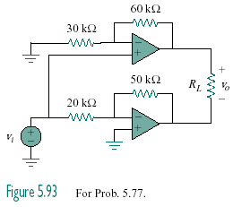
Figure 5.109
For Prob. 5.92.

